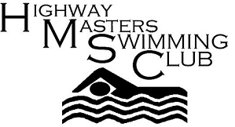

NATIONALS – CAPE TOWN 2012 – REPORT BACK 24th March 2012
It’s hard to believe that Nationals 2012 has come and gone.
What remains are the wonderful memories of our time together. The camaraderie and support was wonderful.
We looked so good in our Highway T shirts at the Gala and our gold chokers and diamond pendants at the Awards evening (a big thank you to Debbie) and being part of such a caring and supportive group of swimmers is a wonderful feeling.

Each member of the “Highway Family” had their own goals and each one was able to feel that they had achieved in their own way.

Our relay teams were wonderful and the excitement was enormous. Our men’s teams of Brendan, Theo, Huibert, Tony and Wolfgang were excellent and our ladies were sensational.
The first relay of the 4 x 100 free mixed relay was dynamic and so exciting to watch and that set the tone for the rest of the competition.

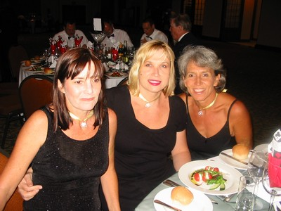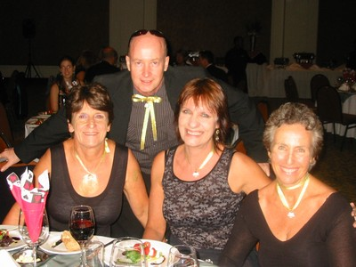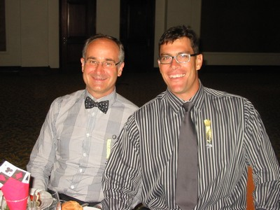
Dawn B, Debbie and Peta. Bev, Brendan, Maretha& Heather. Wolfgang and Theo
We can all feel very proud of our efforts and the results speak for themselves. Many of our members swam personal best times and the medal count was vast!! Very well done to all.

A very big welcome to our ‘first-time’ Nationals attendees:
Debbie, Dawn Blakeway, Dawn Rode and Maretha Heymans...

A very big welcome back to Theo van der Merwe and Estelle Geraty. It was great having you with us again.
It was wonderful to have the Baker/Thatcher families with us and it felt like old times.
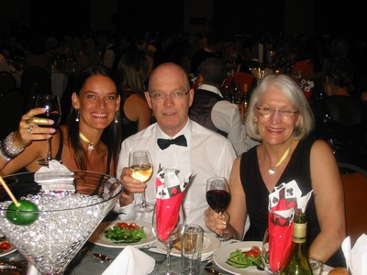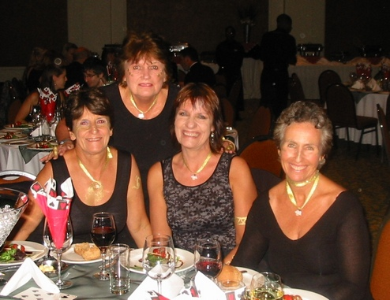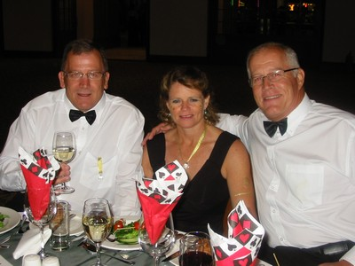
The Thatchers Tony B, Terry T and Ray Baker.
So many of our swimmers achieved outstanding results and a very special mention must go to Bev Shuttleworth and Jenny Ireland who both swam SAMS qualifying times. Well done to you both and good luck to Bev and Barbara Bowley who will be attending World Masters in Riccione in June.

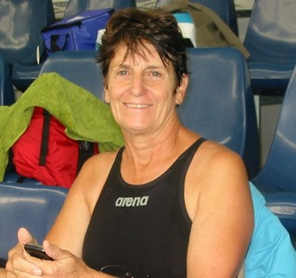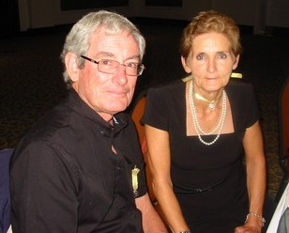
Bev Shuttleworth Peter and Jenny Ireland

Ann was not able to swim but she devoted countless hours to time keeping and being a mentor to University of Western Cape Sports Science students. Without our precious time-keepers, we could not have a gala.

Huibert moved into a new age group and swam like a 20 year old and not the 70 year old that he is. He puts us to shame with his fast times and shows us that age is not a reason to slow down.

Bev and Terry swam the1 km open water swim at Blue Rock Dam near the bottom of Sir Lowry’s Pass and both did very well, Bev winning her category and Terry coming second.

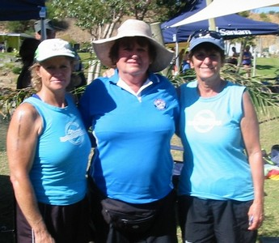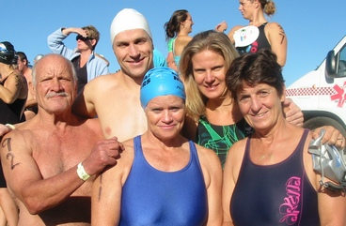
Ann (centre) congratulating Terry and Terry and Bev with Adrian, Kieran
Bev and Jill (East Coast0

All the results are available on the S A Masters Swimming website.www.samastersswimming.com

It was such a whirlwind for 4 days and now it’s done. What’s next? ………… Port Elizabeth for March 2013. Hope to see you all there.

Some of the Proud Lady Medal winners by Dawn Rode
Bev, Terry, Dawn Blakeway Heather and Debbie
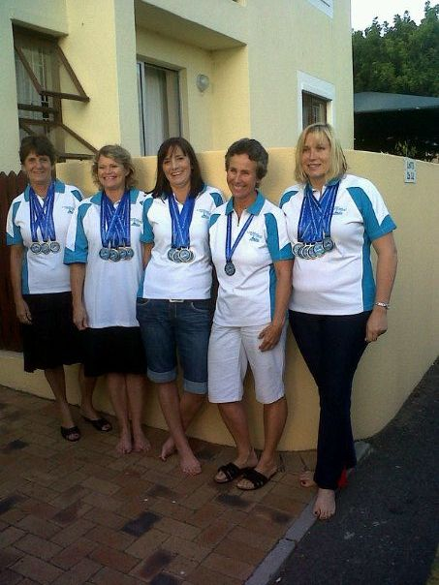

Cheers for now.

Heather Goldstein (Chairperson)

Ann Gray (Photos)

