Region / Club Committee contact details for the 2015-2016 season
FREE STATE MASTERS SWIMMING ASSOCIATION |  |  | 
President/  Chairperson | Name: | Gwyn Guiney | 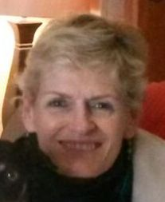
President/  Chairperson | Email: | gwyn@telkomsa.net
President/  Chairperson | Cell no: | 082 559 6127
Vice-President/  Chairpeson | Name: | Amelia Scott | 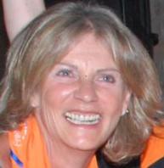
Vice-President/  Chairpeson | Email: | info@ridges.co.za
Vice-President/  Chairpeson | Cell no: | 082 5588 258
Secretary and Registration Secretary | Name: | Barbara Hickling | 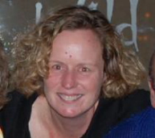
Secretary and Registration Secretary | Email: | ptc@lantic.net
Secretary and Registration Secretary | Cell no: | 082 900 5698
Treasurer | Name: | Barbara Hickling
Treasurer | Email: | ptc@lantic.net
Treasurer | Cell no: | 082 900 5698
Liaison with Free State Aquatics | Name: | Antoinette van Niekerk | 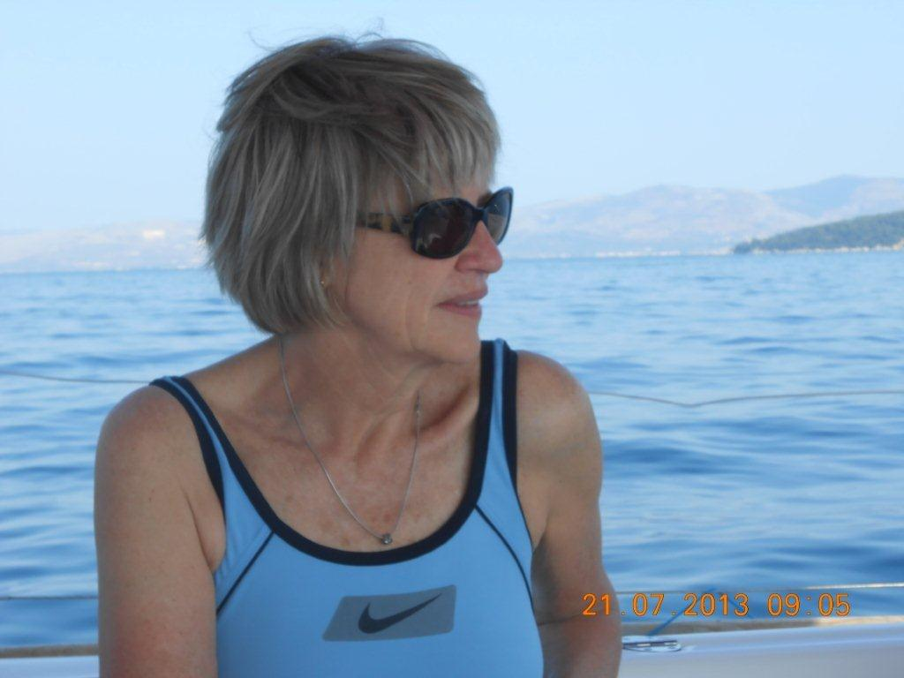
Liaison with Free State Aquatics | Email: | eacachet@intekom.co.za
Liaison with Free State Aquatics | Cell no: | 082 457 2359
Liaison with Free State Aquatics | Home no:
facebook | Name: | Free State Masters Swimming Club | 
facebook | Email:
facebook | Cell no:
facebook | Home no:

