Regional Committee contact details for the 2015-2016 season
Gauteng Masters Swimming
<ADDRESS>

President | Name: | Karen Kennedy | 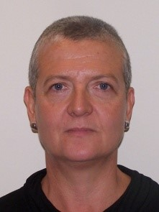
 | Email: | kennedy@yebo.co.za
 | Cell no: | 083 375 7503
Vice-President | Name: | Guy Harker | 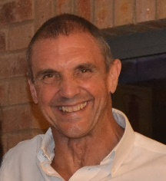
 | Email: | guyh@summercon.co.za
 | Cell no: | 083 461 0884
Secretary | Name: | Carole Bridges | 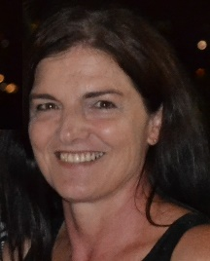
 | Email: | wahoosecretary@gmail.com
 | Cell no: | 082 940 6628
Treasurer | Name: | Quirin Köhler | 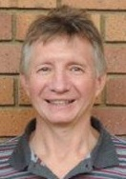
 | Email: | quirin@global.co.za
 | Cell no: | 083 382 0011

