CLUB Committee contact details for the 2015-2016 season
Nelson Mandela Bay Aquatics - Masters |  |  | logo
Address: If applicable |  |  | logo
President/  Chairperson | Name: | PJ Duffy | 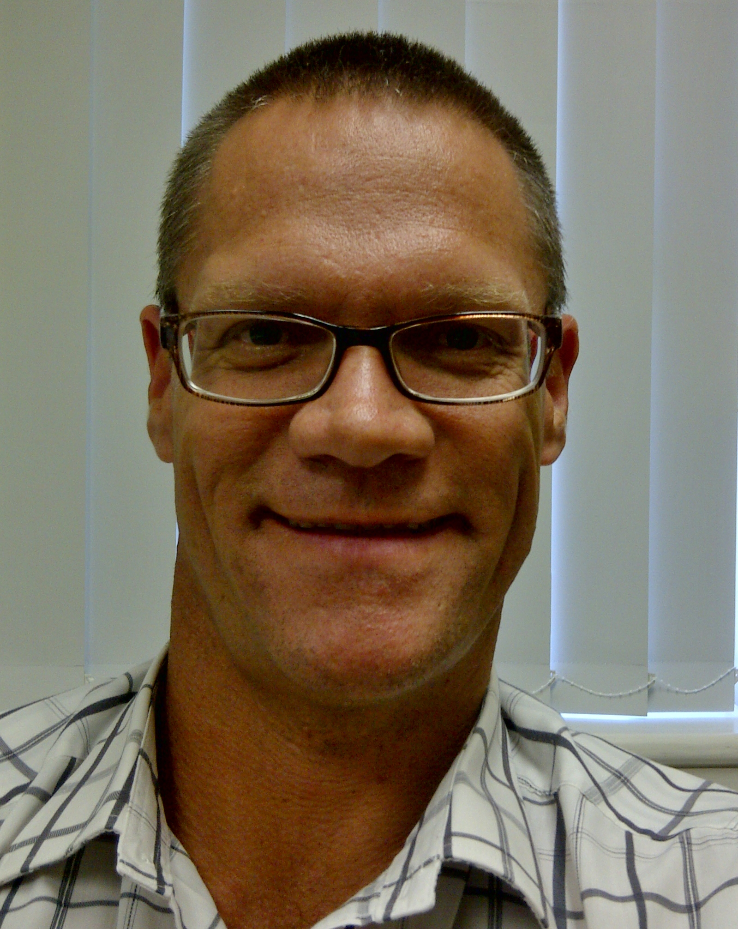
President/  Chairperson | Email: | pjduffy@broll.com
President/  Chairperson | Cell no: | 0829026021
President/  Chairperson | Home no:
Vice-President/  Chairpeson | Name: | Elsa Craig | 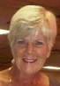
Vice-President/  Chairpeson | Email: | elsacra@telkomsa.net
Vice-President/  Chairpeson | Cell no: | 0824130517
Vice-President/  Chairpeson | Home no: | 0413792137
Secretary | Name: | Denise Bosman | pic
Secretary | Email: | bosmead@gmail.com | pic
Secretary | Cell no: | 0845118660 | pic
Secretary | Home no: |  | pic
Treasurer | Name: | Angela Finlay | pic
Treasurer | Email: | angela@admedical.com | pic
Treasurer | Cell no: | 0836554488 | pic
Treasurer | Home no: |  | pic
Registration Sec. | Name: | Elsa Craig | pic
Registration Sec. | Email: | elsacra@telkomsa.net | pic
Registration Sec. | Cell no: | 0824130517 | pic
Registration Sec. | Home no: | 0413792137 | pic
Newsletter | Name: |  | pic
Newsletter | Email: |  | pic
Newsletter | Cell no: |  | pic
Newsletter | Home no: |  | pic
Nationals | Name: |  | pic
Nationals | Email: |  | pic
Nationals | Cell no: |  | pic
Nationals | Home no: |  | pic
Gala’s | Name: |  | pic
Gala’s | Email: |  | pic
Gala’s | Cell no: |  | pic
Gala’s | Home no: |  | pic
Website | Name: |  | pic
Website | Email: |  | pic
Website | Cell no: |  | pic
Website | Home no: |  | pic

